EXPLORATORY DATA ANALYSIS
OF SMART HOSPITAL APPOINTMENTS
A Python-based Data Analysis Project

Submitted by: Rhema Mary Seth
Course: Program In AI Driven Data Analytics – DA54

INDEX

- Abstract---------------------------------------------------------------------------------------------------------1
- Introduction--------------------------------------------------------------------------------------------------- 2
  - Problem Statement----------------------------------------------------------------------------------- 2
  - Project Objectives------------------------------------------------------------------------------------- 2
  - Scope----------------------------------------------------------------------------------------------------- 2
- Dataset Description------------------------------------------------------------------------------------------3
  - Main Dataset Fields----------------------------------------------------------------------------------- 3
- Libraries and Tools Used------------------------------------------------------------------------------------3
- Methodology-------------------------------------------------------------------------------------------------- 4
- Data Cleaning and Preprocessing-------------------------------------------------------------------------4
  - Column names and Calculated Fields------------------------------------------------------------- 4
  - Missing Values------------------------------------------------------------------------------------------ 4
  - Duplicate Records--------------------------------------------------------------------------------------4
  - Data Types------------------------------------------------------------------------------------------------5
  - Standardising Categorical Values-------------------------------------------------------------------5
- Outlier Analysis----------------------------------------------------------------------------------------------- 5
- Exploratory Data Analysis (EDA)-------------------------------------------------------------------------- 6
  - Numerical Summary-----------------------------------------------------------------------------------6
    - Distribution Analysis-------------------------------------------------------------------------- 6
    - Group - by Average Analysis---------------------------------------------------------------- 6
  - Categorical Analysis----------------------------------------------------------------------------------- 7
    - Percentage Analysis--------------------------------------------------------------------------- 7
    - Correlation Analysis--------------------------------------------------------------------------- 8
- Visualisation and Interpretation-------------------------------------------------------------------------- 9
  - Bar Chart – Appointment Status-------------------------------------------------------------------- 9
  - Line Chart – Monthly appointment Status------------------------------------------------------- 9
  - Histogram – Patient Age Distribution-------------------------------------------------------------10
  - Box Plot – Medicine Cost Outlier Analysis-------------------------------------------------------10
  - Scatter Plot – Medicine Cost vs Total Bill ------------------------------------------------------- 11
  - Pie Chart – Gender Distribution--------------------------------------------------------------------11
  - Correlation Heatmap – Numerical Variables----------------------------------------------------12
  - Bar Chart – Department - wise Patient Count (Plotly)----------------------------------------12
  - Scatter Plot – Doctor Experience vs Consultation Fee (Plotly)------------------------------13
  - Violin Plot – Satisfaction by Appointment Status (Plotly)---------------------------------13
- Key Findings and Insights-----------------------------------------------------------------------------------14
- Conclusion------------------------------------------------------------------------------------------------------14
- Limitations------------------------------------------------------------------------------------------------------14
- Future Recommendations----------------------------------------------------------------------------------15
- References------------------------------------------------------------------------------------------------------15

1. ABSTRACT

The Exploratory Data Analysis of Smart Hospital Appointments project examines patient appointment records to understand patterns in patient demographics, appointment types and outcomes, hospital departments, doctor experience, healthcare expenses, and patient satisfaction. The analysis is carried out in Python using Pandas and NumPy for data handling, and Matplotlib, Seaborn, and Plotly for visualisation.
The analysis begins by loading the dataset and reviewing its structure, column types, missing values, duplicate records, and descriptive statistics. Data preparation includes standardising column names, renaming selected fields, calculating total bills from consultation fees, medicine costs and laboratory test costs, handling missing values, removing duplicate rows, converting data types, and standardising selected categorical values. Unusual values in age, doctor experience and consultation fee are examined, and records outside the chosen validation ranges are filtered.
Exploratory analysis uses descriptive statistics, group averages, category counts, percentage distributions and correlation coefficients. Visualisations include an appointment-status bar chart, monthly appointment line chart, age histogram, medicine-cost box plot, medicine-cost versus total-bill scatter plot, gender pie chart, numerical correlation heatmap, department-wise patient-count bar chart, doctor-experience versus consultation-fee scatter plot, and a violin plot comparing satisfaction scores by appointment status.
Key results recorded in the analysis include a mean patient age of approximately 44.84 years, average satisfaction of approximately 9.70 out of 10, and completed appointments accounting for 82.74% of records. Medicine cost and total bill show a very strong positive correlation (about +0.963), while doctor experience and consultation fee also show a very strong positive correlation (about +0.942). These findings describe patterns in this dataset and should not be interpreted as proof of causation or as representative of all hospitals.

2. INTRODUCTION

Healthcare organisations generate data through appointments, patient registration, clinical services, billing and feedback. Examining such data can help describe how services are used, how expenses vary, and how patient feedback is distributed. However, raw data may contain missing values, repeated records, inconsistent category labels and values that require validation before analysis.
This project uses a Smart Healthcare Patient Appointment Dataset as a practical dataset for exploratory analysis. It combines patient details, appointment information, doctor experience, insurance status, medical costs and satisfaction scores. Python provides a reproducible workflow for inspecting, cleaning, summarising and visualising these fields.

2.1 Problem Statement
The raw appointment dataset contains incomplete values in some fields, repeated records, inconsistent formatting and unusual numerical values. Without preparation, these issues can affect summary statistics and visual interpretation. In addition, the relationships between appointment outcomes, costs, doctor experience and satisfaction are not immediately apparent from a raw table. The project therefore needs a structured cleaning and exploratory analysis process to identify patterns and communicate them clearly.

2.2 Project Objectives
- Inspect the dataset structure, dimensions, column names, data types and completeness.
- Handle missing values and duplicate records using the rules.
- Standardise column names, selected categorical values and relevant data types.
- Calculate a total_bill field from consultation_fee, medicine_cost and lab_test_cost.
- Investigate unusual numerical values and apply the filtering rules.
- Summarise numerical fields using mean, median, minimum, maximum, standard deviation and quartiles.
- Compare total bills and satisfaction across departments and consultation fees across doctor experience levels.
- Analyse category frequencies and percentage distributions for key categorical fields.
- Explore linear relationships between numerical variables using correlation coefficients.
- Communicate findings through static and interactive graphs.

2.3 Scope
The work is an exploratory analysis of the healthcare dataset. It describes patterns within the available records; it does not build a predictive model, establish causal relationships, evaluate clinical outcomes, or independently verify the dataset's original collection process.

3. DATASET DESCRIPTION
The dataset is taken from the source - Kaggle Smart Healthcare Patient Appointment Dataset. The original data loaded in the analysis contains 2,716 records and 18 columns. During preprocessing, column names are standardised, two fields are renamed, and a calculated total_bill column is added. After the documented cleaning and filtering steps, this reports a working dataset with 2,706 records and 19 columns.

3.1 Main Dataset Fields
Field | Meaning / use in analysis
patient_id | Patient or record identifier; converted to string.
age | Patient age in years.
gender | Gender category used for percentage analysis.
city | City recorded for the patient.
bmi | Body mass index, a numerical patient attribute.
chronic_disease | Chronic disease category; missing values represented as Unknown.
appointment_type | Scheduled, Walk-in, Emergency or Unknown.
department | Hospital department associated with the record.
symptoms | Recorded symptom category; missing values represented as Unknown.
severity_level | Severity category; formatting standardised.
doctor_experience_years | Doctor experience in years; missing values filled with the median.
consultation_fee | Consultation fee recorded for the appointment.
insurance | Insurance status, with formatting standardised.
appointment_month | Month of appointment, used for monthly counts.
appointment_status | Completed, No Show or Cancelled status.
satisfaction_score | Patient satisfaction score; missing values filled with the median.
medicine_cost | Medicine-related expense.
lab_test_cost | Laboratory test expense; renamed from test_cost.
total_bill | Calculated sum of consultation fee, medicine cost and laboratory test cost.

4. LIBRARIES AND TOOLS USED
Library / tool | Role in this project
Python | Programming language used to run the analysis.
Google Colab | Analysis environment for running Python cells.
Google Drive | Used to mount Drive and load the CSV file.
Pandas (pd) | Loads CSV data and performs data cleaning, grouping, counting and tabular summaries.
NumPy (np) | Imported for numerical and array-related operations; the analysis's main analysis primarily uses Pandas.
Matplotlib (plt) | Creates bar, line, histogram and pie visualisations.
Seaborn (sns) | Creates statistical visualisations such as box plots, scatter plots and correlation heatmaps.
Plotly Express (px) | Creates interactive department-wise bar, doctor experience scatter and satisfaction violin plots.

5. METHODOLOGY
The workflow follows a sequence from loading the CSV file to cleaning, exploratory analysis and visualisation. The analysis first imports the libraries, mounts Google Drive and reads the CSV. It then inspects the data with methods such as info(), head(), tail(), shape, columns, dtypes, describe(), isnull().sum() and duplicated().
- Load and inspect the original dataset.
- Standardise column names and create the calculated total_bill field.
- Handle missing values and remove duplicate rows.
- Convert selected columns to appropriate data types and standardise categorical labels.
- Inspect numerical summaries and identify unusual values.
- Apply the documented age, doctor-experience and consultation-fee filters.
- Perform numerical, categorical, group-average, distribution, percentage and correlation analysis.
- Create visualisations to communicate the main patterns.

6. DATA CLEANING AND PREPROCESSING
Data cleaning prepares records for analysis by addressing missing values, duplicate rows, inconsistent labels, unsuitable data types and implausible values. The analysis carries out the following steps.

6.1 Column names and Calculated Fields
Column names are stripped of leading/trailing spaces, converted to lowercase and spaces are replaced with underscores. The analysis renames patient_satisfaction_score to satisfaction_score and test_cost to lab_test_cost. It then calculates total_bill as the sum of consultation_fee, lab_test_cost and medicine_cost.

6.2 Missing Values
Column(s) | Missing-value treatment
doctor_experience_years | Filled with the median of the column.
satisfaction_score | Filled with the median of the column.
city | Filled with the most frequent category (mode).
chronic_disease | Filled with the text Unknown.
appointment_type | Filled with the text Unknown.
symptoms | Filled with the text Unknown.

Before cleaning, the analysis output reports 20 missing city values, 1,236 missing chronic_disease values, 3 missing appointment_type values, 6 missing symptoms values, 10 missing doctor_experience_years values and 10 missing satisfaction scores. The analysis fills these fields using the rules above and rechecks missing-value counts.

6.3 Duplicate Records
The initial duplicate check identifies 4 duplicate rows. The analysis removes duplicates using drop_duplicates() and confirms that the duplicate count becomes zero. Removing repeated rows helps avoid counting the same record more than once.

6.4 Data Types
Column names such as patient_id is converted to string because it is an identifier rather than a quantity. consultation_fee, medicine_cost, lab_test_cost and total_bill are converted to floating-point values. doctor_experience_years is converted to integer after missing values are filled.

6.5 Standardising Categorical Values
The gender, appointment_type, severity_level and insurance columns are cleaned by stripping surrounding spaces and applying title-style capitalisation with str.capitalize(). This helps prevent categories such as differently capitalised versions of the same label from being counted separately.

7. OUTLIER ANALYSIS
An outlier is a value that lies unusually far from the main distribution. The analysis explains the Interquartile Range (IQR) method and checks the age, doctor_experience_years and consultation_fee columns. The original summary reveals clearly unusual values, including age 201, doctor experience 90 years and consultation fee 5,000.

IQR Method
Q1 is the 25th percentile and Q3 is the 75th percentile. The interquartile range is IQR = Q3 − Q1. The conventional lower and upper fences are Q1 − 1.5 × IQR and Q3 + 1.5 × IQR. Values beyond these fences are flagged as potential outliers.
Column | Q1 | Q3 | IQR | Upper IQR fence | Values flagged in analysis
age | 22 | 67 | 45 | 134.5 | Two records with age 201
doctor_experience_years | 8 | 23 | 15 | 45.5 | Two records with experience 90
consultation_fee | 460 | 757 | 297 | 1,202.5 | Two records with fee 5,000

Filtering Applied
The analysis's filtering cell removes records with age outside 0–100, doctor experience outside 0–60, and consultation fees below 0 or at least 1,000. This removes the clearly invalid values described above and results in 2,706 rows and 19 columns. The post-filter summary reports age from 1 to 89, doctor experience from 1 to 30 years, and consultation fees from ₹220 to ₹998.
Methodological note: Although the analysis introduces IQR fences, the filtering code applies explicit validation ranges rather than applying the calculated IQR fences directly. It also does not explicitly filter total_bill using its own IQR bounds. Therefore, the report describes the executed filters accurately and does not claim that every IQR-flagged value was removed by an automated IQR mask.

Medicine Cost Box Plot
The visualisation section plots medicine_cost with a Seaborn box plot. The recorded range is ₹100 to ₹19,984. The maximum is described in the analysis as a suspected high-cost outlier to check visually. A maximum value alone does not prove that it is an outlier; the box-plot whiskers or IQR limits should be checked before classifying it definitively.
8. Exploratory Data Analysis (EDA)

Exploratory Data Analysis (EDA) is used to summarise the dataset, understand category frequencies and examine relationships before drawing conclusions. The analysis includes numerical summaries, group-by averages, categorical counts, distribution analysis, percentage analysis and correlation analysis.

8.1 Numerical Summary
Variable | Mean | Median | Minimum | Maximum
Age (years) | 44.84 | 45.00 | 1 | 89
BMI | 24.09 | 23.90 | 15.0 | 39.8
Doctor experience (years) | 15.52 | 15.00 | 1 | 30
Consultation fee | ₹608.10 | ₹611.00 | ₹220 | ₹998
Satisfaction score | 9.70 | 10.00 | 7.6 | 10.0
Medicine cost | ₹4,989.13 | ₹2,826.50 | ₹100 | ₹19,984
Lab test cost | ₹3,864.72 | ₹2,290.00 | ₹3 | ₹14,991
Total bill | ₹9,461.95 | ₹5,818.50 | ₹474 | ₹34,669

The mean age (44.84) and median age (45) are close. Satisfaction scores are high overall, with a mean of 9.70 and median of 10. Medicine cost, laboratory cost and total bill show large ranges and standard deviations, indicating substantial variation in expenses across records.

8.1.1 Distribution Analysis
The describe() output provides count, mean, standard deviation, minimum, quartiles and maximum for numerical columns. The average age and bmi was found to be 45 and 24.09 respectively. Doctors had an average experience of approximately 16 years. The total bill mean (₹9,461.95) is considerably higher than its median (₹5,818.50), suggesting that some high bills pull the average upward. The average satisfaction score was high at 9.70 out of 10. Medicine cost shows a similar difference between mean and median, indicating a right-skewed pattern may be present.

8.1.2 Group-by Average Analysis
The analysis compares average total bills by department, average consultation fees by doctor experience and average satisfaction by department.

Analysis | Analysis result | Interpretation
Average total bill by department | Highest: Cardiology ₹14,646.06; lowest: Neurology ₹5,074.51 | Average billed amounts differ across departments in this dataset.
Average consultation fee by experience | About ₹318.29 at 1 year; ₹900.85 at 30 years | Average fees generally increase as recorded doctor experience increases.
Average satisfaction by department | Highest: Cardiology 9.89; lowest: Neurology 9.56 | Scores are high in all departments, with modest differences.

8.2 Categorical Analysis
Categorical analysis counts records in fields such as gender, city, chronic disease, appointment type, department, symptoms, severity level, insurance, appointment month and appointment status. The analysis uses value_counts() to show the frequency of categories and mode() to identify the most frequent category.
The most frequent category is useful for understanding the dataset's composition. However, category frequency alone does not indicate whether a group has better health outcomes or service quality; it only describes how often a category appears in the supplied records.

8.2.1 Percentage Analysis
Percentage analysis converts category counts into a share of the records. The analysis calculates the percentage as (category count ÷ total records) × 100 for gender, appointment type, insurance and appointment status.

Category field | Category | Percentage
Gender | Male | 50.22%
Gender | Female | 49.78%
Appointment type | Scheduled | 54.40%
Appointment type | Walk-in | 31.45%
Appointment type | Emergency | 14.04%
Appointment type | Unknown | 0.11%
Insurance | Yes | 59.76%
Insurance | No | 40.24%
Appointment status | Completed | 82.74%
Appointment status | No Show | 12.42%
Appointment status | Cancelled | 4.84%

Interpretation
- The gender split is nearly even, with male records only slightly more frequent.
- Scheduled appointments form the largest appointment-type group, followed by walk-ins and emergency appointments.
- Insurance is recorded as Yes for 59.76% of records and No for 40.24%.
- Completed appointments account for most records; no-shows and cancellations are smaller groups.

8.2.2 Correlation Analysis
Correlation analysis measures the strength and direction of linear association between numerical variables. The analysis uses the DataFrame corr() method and displays the results rounded to four decimal places. A coefficient near +1 indicates a strong positive association, near −1 a strong negative association, and near 0 a weak linear association.

Variable pair | Correlation | Interpretation
Medicine cost – Total bill | +0.9626 | Very strong positive relationship
Doctor experience – Consultation fee | +0.9418 | Very strong positive relationship
Lab test cost – Total bill | +0.9294 | Very strong positive relationship
Medicine cost – Lab test cost | +0.7953 | Strong positive relationship
Satisfaction score – Total bill | +0.4335 | Moderate positive relationship
Satisfaction score – Lab test cost | +0.4159 | Moderate positive relationship
Satisfaction score – Medicine cost | +0.4084 | Moderate positive relationship
Age – BMI | +0.0273 | Very weak positive relationship
Age – Satisfaction score | −0.0073 | Negligible negative linear relationship

Interpretation
The very strong positive correlation between medicine cost and total bill is expected to some extent because medicine cost is one of the components used to calculate total_bill. Similarly, laboratory cost is included in total_bill, so a strong association is not surprising. Doctor experience and consultation fee show a very strong positive relationship in the dataset.
Correlation does not establish cause and effect. The small correlations between age and BMI, and between age and satisfaction, indicate little linear association in this dataset. A correlation near zero does not rule out a nonlinear relationship or an association with other variables.

9. Visualisation & Interpretation
The analysis uses static charts from Matplotlib and Seaborn as well as interactive Plotly charts. Graphs make patterns easier to recognise than inspecting raw rows alone. The following descriptions and insights reflect the code and findings recorded in the analysis.
9.1 Bar Chart – Appointment Status
Analysis type: Univariate Analysis
Taller bars represent more records. The completed category is visibly the largest, while cancelled appointments form the smallest group.
Completed appointments account for 82.74%, no-shows for 12.42%, and cancellations for 4.84%. The dataset therefore contains substantially more completed appointments than missed or cancelled appointments.

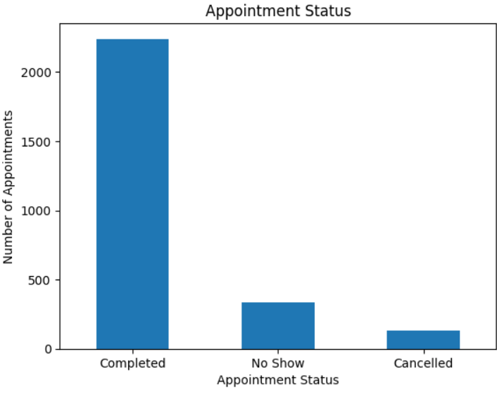
Fig 1. Appointment Status by Number of Appointments

9.2 Line Chart – Monthly Appointment Trends
Analysis type: Univariate Analysis
Each marker represents one month's count; rises and falls in the line indicate changes in volume.
The analysis identifies June as the month with the highest appointment count, slightly above November, and September as the month with the lowest count. These are descriptive monthly counts; the data does not establish the reason for the differences.

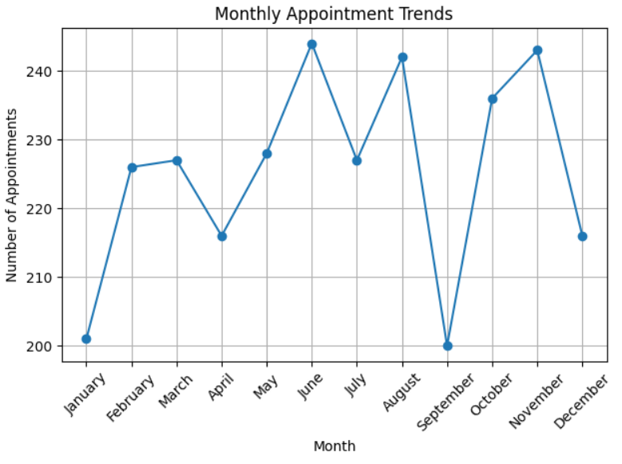
Fig 2. Monthly Appointments by Number of Appointments
9.3 Histogram – Patient Age Distribution
Analysis type: Univariate Analysis
The height of each bar indicates how many patient records fall within its age interval.
Mean age is 44.84 years, median age is 45 years, and the cleaned age range is 1–89 years. The close mean and median suggest the centre of the age distribution is around 45 years.

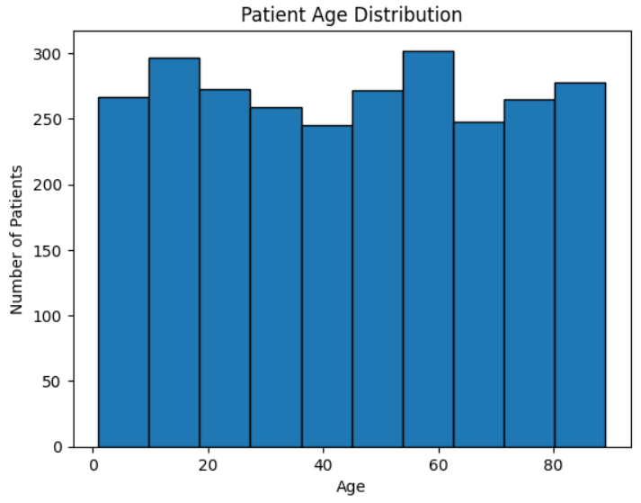
Fig 3. Number of Patients vs Age

9.4 Box Plot – Medicine Cost Outlier Analysis
Analysis type: Univariate Analysis
The box contains the middle half of values, the central line marks the median, and points beyond whiskers may be potential outliers.
Medicine cost ranges from ₹100 to ₹19,984. The maximum is a candidate for investigation, but should be called an outlier only if the plotted whiskers or IQR bounds support that classification.

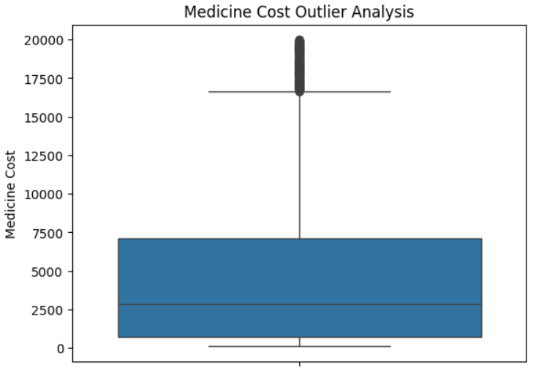
Fig 4. Medical Cost Outlier
9.5 Scatter Plot – Medicine Cost vs Total Bill
Analysis type: Bivariate Analysis
An upward point pattern indicates a positive association.
The correlation is approximately +0.963, showing a very strong positive relationship. Because medicine cost is included in the total_bill formula, this relationship is partly built into the calculation.

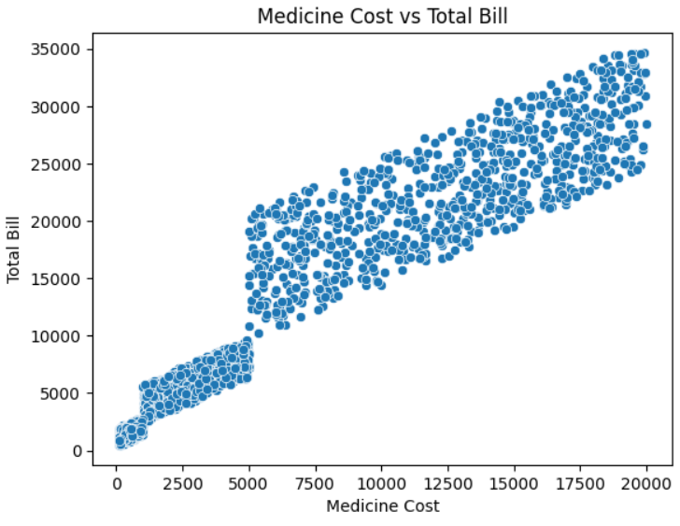
Fig 5. Medicine Cost vs Total Bill

9.6 Pie Chart – Gender Distribution
Analysis type: Univariate Analysis
Each slice represents a category, and the labels show each category's percentage.
Male records account for 50.22% and female records for 49.78%. The distribution is almost evenly split.

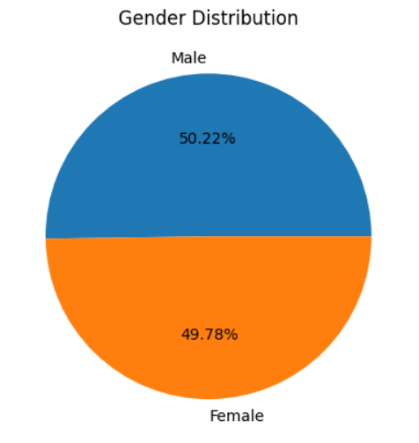
Fig 6. Gender Distribution
9.7 Correlation Heatmap – Numerical Variables
Analysis type: Multivariate Analysis
Values near +1 or −1 indicate stronger linear relationships, while values near zero indicate weaker linear relationships. Colours make strong patterns easier to spot.
Medicine cost–total bill (+0.963), doctor experience–consultation fee (+0.942) and lab test cost–total bill (+0.929) are the strongest positive pairs reported.
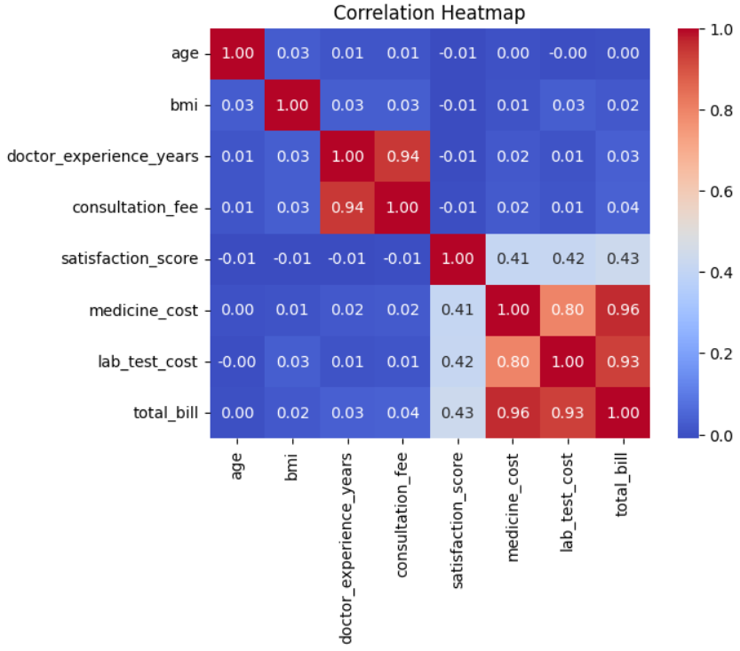
Fig. 7 Correlation Heatmap

9.8 Bar Chart – Department-wise Patient Count (Plotly)
Analysis type: Univariate Analysis
Each bar represents a department; hovering over bars can reveal the displayed count.
The analysis reports Cardiology as the department with the highest patient count and Orthopedics as the department with the lowest patient count.

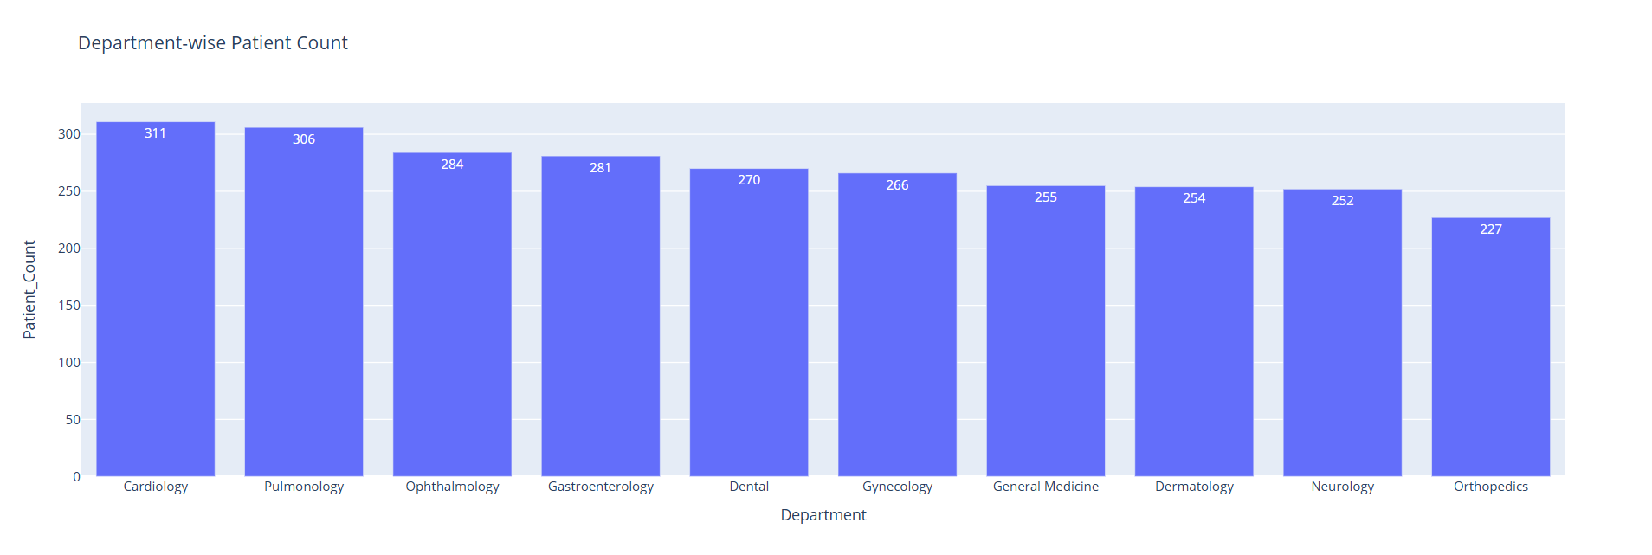
Fig. 8 Department wise Patient Count
9.9 Scatter Plot – Doctor Experience vs Consultation Fee (Plotly)
Analysis type: Bivariate Analysis
An upward pattern indicates higher experience tends to coincide with higher fees.
The correlation is approximately +0.942, a very strong positive relationship. The grouped averages also rise from about ₹318 at one year of experience to about ₹901 at 30 years.

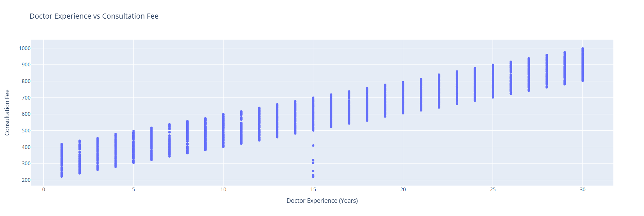
Fig. 9 Doctor Experience vs Consultation Fee

9.10 Violin Plot – Satisfaction by Appointment Status (Plotly)
Analysis type: Bivariate Analysis
Wider sections indicate score values where observations are more concentrated. The box and tails help compare central values and variation.
Scores are generally high, with many observations concentrated around 9.6–10. The analysis's plot description indicates a wider spread for No Show records, suggesting greater variation in that group.

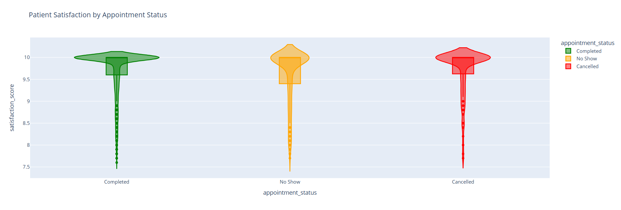
Fig. 10 Satisfaction by Appointment Status

10. Key Findings & Insights

- The working dataset contains 2,706 records and 19 columns after cleaning and adding total_bill.
- The analysis identified and removed four duplicate records.
- Missing numerical values in doctor experience and satisfaction were filled with medians; missing city values were filled with the mode; selected categorical missing values were labelled Unknown.
- Mean patient age is 44.84 years and median age is 45 years.
- Mean satisfaction score is 9.70 out of 10, and the median is 10, indicating high recorded satisfaction scores.
- Completed appointments represent 82.74% of records; no-shows represent 12.42%, and cancellations 4.84%.
- Scheduled appointments are the largest appointment-type category at 54.40%, followed by Walk-in at 31.45% and Emergency at 14.04%.
- Insurance is recorded as Yes for 59.76% of records and No for 40.24%.
- Cardiology has the highest average total bill (about ₹14,646) among the departments shown; Neurology has the lowest (about ₹5,075).
- Cardiology has the highest average satisfaction score (about 9.89), while Neurology has the lowest (about 9.56); scores remain high across departments.
- Medicine cost and total bill have a very strong positive correlation (+0.963), and lab test cost and total bill are also strongly correlated (+0.929).
- Doctor experience and consultation fee show a very strong positive correlation (+0.942).

11. Conclusion

This project demonstrates an end-to-end introductory data analysis workflow for a healthcare appointment dataset. Data inspection and cleaning created a consistent working dataframe, while descriptive statistics and category summaries described the patients, appointment outcomes and expenses represented in the data. Visualisations helped communicate monthly trends, age distribution, medicine-cost variation, department volumes and numerical relationships.
The strongest reported associations are between medicine cost and total bill, lab test cost and total bill, and doctor experience and consultation fee. The percentage analysis also shows that completed appointments form the majority of records and that scheduled appointments are the most common appointment type. These findings can guide further questions about cost composition, appointment attendance and service patterns, but they should be treated as descriptive findings rather than causal conclusions.

12. Limitations

- The analysis depends on the quality and completeness of the supplied dataset and does not independently verify the data source or collection procedure.
- The analysis does not provide a detailed data dictionary for every category or confirm whether each row represents a unique patient or a single appointment.
- Filling missing categories with Unknown or the mode/median can affect distributions and may hide some uncertainty in the original data.
- The outlier section describes the IQR method, but the executed filters use explicit ranges rather than applying IQR fences directly to every selected field.
- The analysis does not explicitly remove total_bill outliers using total_bill-specific IQR limits.
- Correlation measures linear association and cannot establish causality. Correlations between total_bill and its cost components are expected because the total bill is calculated from those components.
- The analysis reports monthly differences but does not establish the reasons behind them or assess statistical significance.
- The results are not necessarily generalisable to other hospitals, regions or time periods.

13. Future Recommendations

- Validate the data dictionary and confirm whether each row represents a patient, an appointment, or a billing event.
- Document the original source, collection period, sampling method and definitions of appointment status and satisfaction score.
- Use explicit IQR masks consistently if IQR-based outlier removal is intended; record the number of rows removed at each step and assess whether removal is appropriate for healthcare data.
- Check total_bill-specific outlier limits and compare results before and after treatment rather than assuming every high bill is erroneous.
- Explore department-wise appointment status and no-show rates, not just department patient counts.
- Analyse appointment trends by month alongside appointment type, department and status to better describe possible operational patterns.
- Use appropriate charts or tables to compare satisfaction across departments and appointment statuses, while checking group sizes.
- Consider a separate validation dataset and suitable statistical tests if the goal moves from description to formal inference.
- Build an interactive dashboard in Plotly or Power BI to let users filter by department, month, appointment type and status.
- Protect privacy by removing direct identifiers from shared reports and ensuring that analysis follows applicable data governance practices.

14. References

1. Smart Healthcare Patient Appointment Dataset. Kaggle. https://www.kaggle.com/datasets/sonalshinde123/smart-healthcare-patient-appointment-dataset
2. Pandas documentation. https://pandas.pydata.org/docs/
3. NumPy documentation. https://numpy.org/doc/
4. Matplotlib documentation. https://matplotlib.org/stable/
5. Seaborn documentation. https://seaborn.pydata.org/
6. Plotly Express documentation. https://plotly.com/python/plotly-express/
7. Google Colaboratory. https://colab.research.google.com/

